Step : 1 Creat a Cloud Account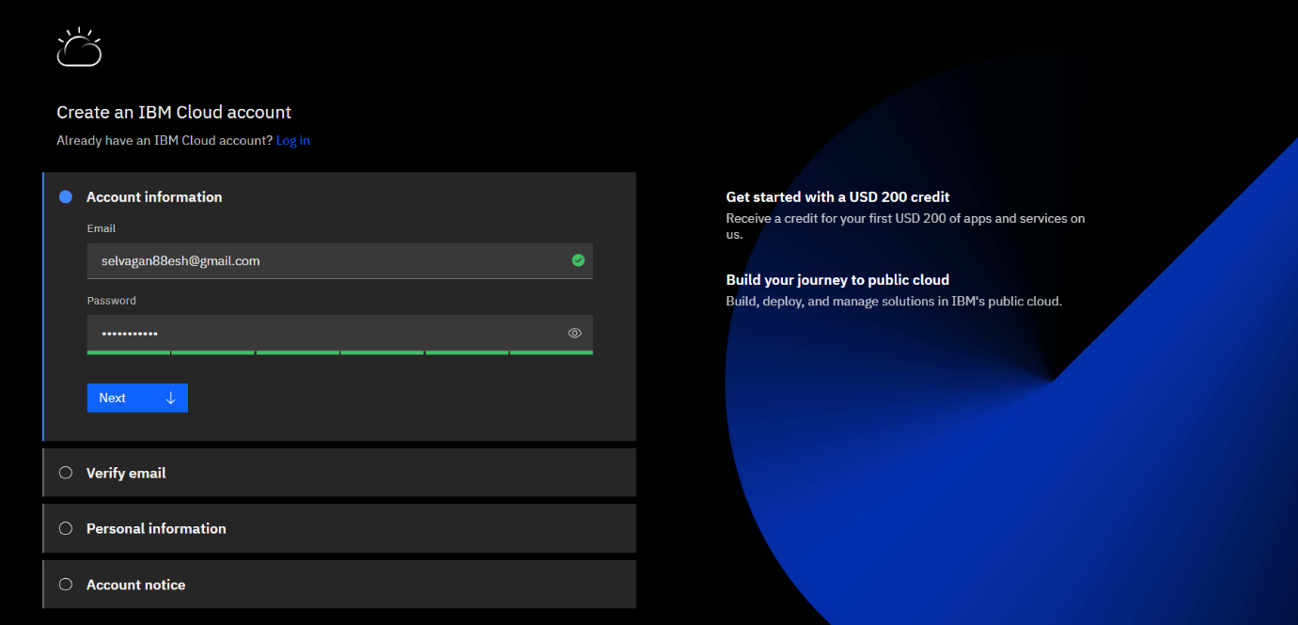

Step : 2 Verify Email

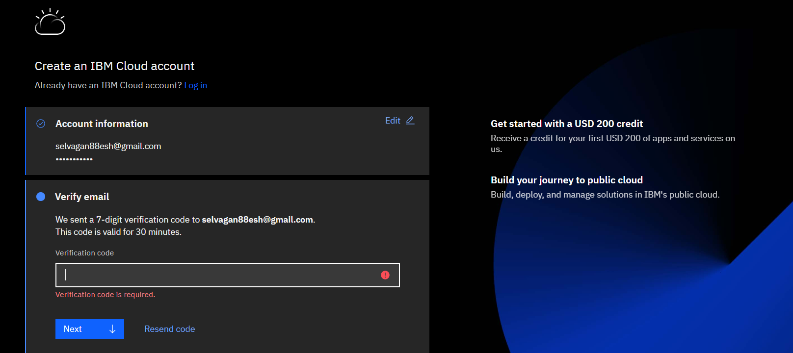

**Step :3 Fill the Personal Details**

**Step :4 Create a Cloud Account Successfully**